* To generate Heading’s IDs and Tags, go to the following URL:  
  <https://dotnetfiddle.net/>  
  and Place below Code in editor.

using System;  
public class Program  
{

public static void Main()  
{

var articleId = "420"; // Put Article Id here.

var headingName = "Is it possible to use automation as a creative tool?"; // place Original Heading Name here

var headingId = headingName.Replace(" ", "-").Replace("?", "").ToLower();

var h2Id = "<h2 id=\""+ headingId +"\">"+ headingName +"</h2>";

var imageName = articleId + "-" + headingId + ".jpg"; // "420-is-it-possible-to-use-automation-as-a-creative-tool.jpg";

var tabelOfContentRow = "<li><a href=\"#" + headingId + "\" title=\""+ headingName + "\">"+ headingName +"</a></li>";

var youtubeVideoId = "vPUn-kn-bcA"; // place Youtube video ID only here.

Console.WriteLine("For h2 Tag :");

Console.WriteLine(h2Id);

Console.WriteLine("\nFor table of content Row :");

Console.WriteLine(tabelOfContentRow);

Console.WriteLine("\nFor Image Name :");

Console.WriteLine(imageName);

Console.WriteLine("\nFor Image Tags :");

Console.WriteLine("<p><img src=\"/img-temp/"+ imageName +"\" style=\"width:100%;\" title=\""+headingName+"\" alt=\""+headingName+"\"></p>");

Console.WriteLine("");Console.WriteLine("");

Console.WriteLine("For YouTube Tags : ");

Console.WriteLine("<p><iframe width=\"100%\" height=\"415\" src=\"https://youtube.com/embed/" + youtubeVideoId + "\" frameborder=\"0\" allow=\"accelerometer; autoplay; encrypted-media; gyroscope; picture-in-picture\" allowfullscreen=\"\"></iframe></p>");

}  
}

* After Place above code, you just need to change **articleId**, **headingName** and **youtubeVideoId**.
  + [Note: youtube video id is the last string after “**v=**”. for example in this video link <https://www.youtube.com/watch?v=VoqjPV-gz9o> video Id is only “**VoqjPV-gz9o**” , So only paste this id in **youtubeVideoId** variable]

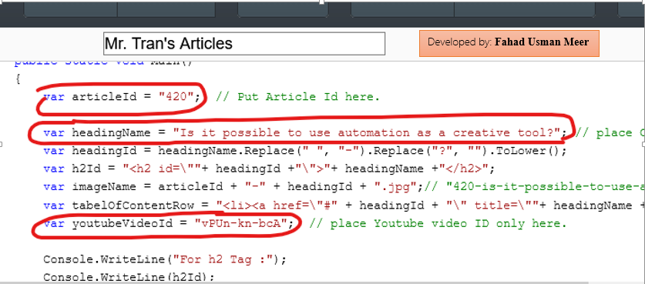

* Now Press the **“RUN”** button and It will create all required tags with IDs, image name and row for table of content in result window. You just need to (Triple click on line for select and) Copy particular results and paste it in particular place in HTML file. ☺

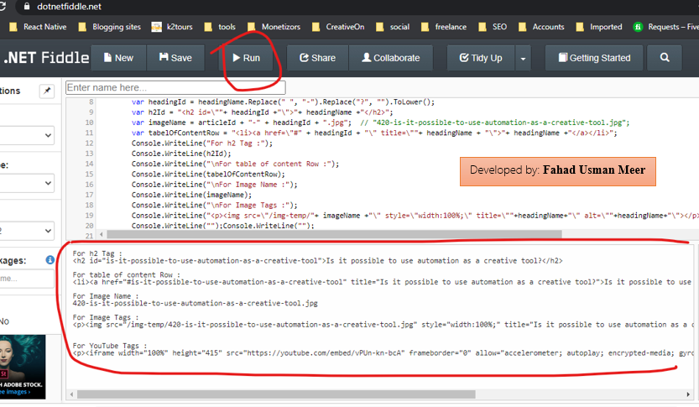

Developed by: **Fahad Usman Meer**